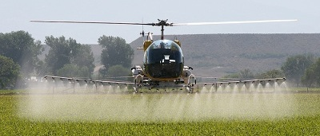

#### Thank you to our Sponsors:

Phone: 970-217-5293

Southeast Colorado Regional Airport (KLAA)

3652 Cnty Rd GG.2

Lamar, CO 81052

(719) 336-7701

Colorado Agricultural Aviation Association

# Operation S.A.F.E Fly-in

September 26, 2021

**Colorado Agricultural Aviation Association, Inc. (CoAAA)**

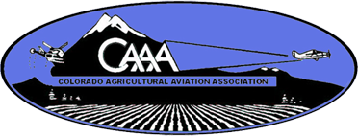



16489 Burghley Ct.

Platteville, CO 80651

Phone: 970-217-5293

[coagav@gmail.com](mailto:coagav@gmail.com)

www.coagav.org

# Tuesday September 27, 2022

**If the weather keeps us from pattern testing on Monday we will roll the event to Tuesday and keep the original schedule in place.**

**Colorado CEU’s Available**

**Kansas CEU’s Available**

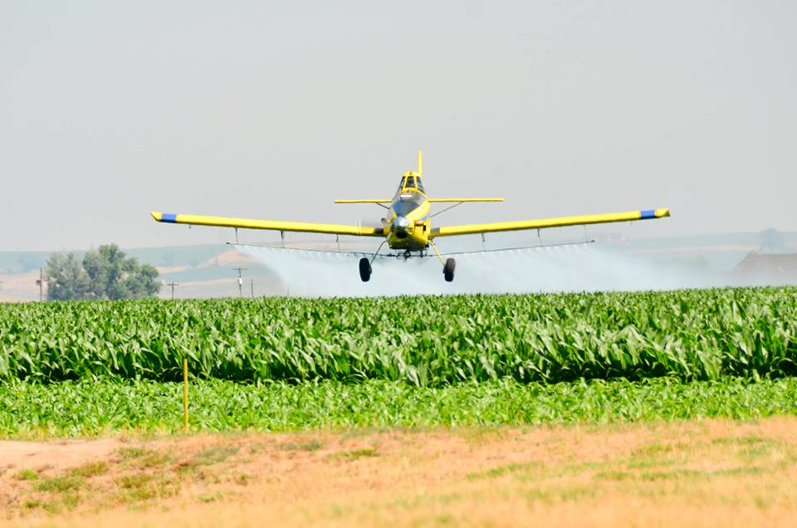

***Meals Provided By:***

***Beverages Provided By:***

***Flight Line/ Equipment Donations:***

#### Fly-In Schedule 2022

PARTICIPANTS MUST BRING PROOF OF AIRCRAFT INSURANCE.

AIRCRAFT MUST BE CLEANED AND NEUTRALIZED. FREE FROM ANY RESIDUE OR ODORS PRIOR TO ATTENDING FLY-IN

# Monday September 26, 2022

**7:00 am**

Breakfast provided by: ***Colorado Agricultural Aviation Association***

* Set up flight line

**8:00 am**

Fly-in begins

**Station 1**

* Pilot Briefing
* Overseeing Load Operations

Loading Equipment provided by:

***Air Care, Inc.***

**Station 2**

* Flight Line Duties
* Drift Tower Operation

**Station 3**

* String Analysis
* Droplet Scan Analysis
* Print out and Pilot Consultation

**11:00 A.M.**

Pattern, Uniformity, and Drift Mitigation*presented by Agri-Spray Consulting*

**12:00 pm**

Lunch provided by:

**1:00 p.m.**

Fly-in Resumes

*All participants must bring proof of Aircraft insurance*

