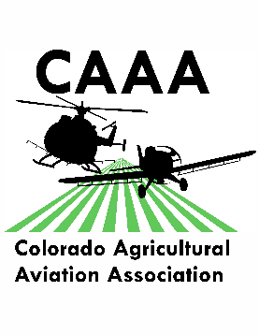Colorado Agricultural Aviation Association

Convention & Trade Show Registration Form

October 15-17, 2019

Doubletree by Hilton

919 7th St.

Greeley, CO 80634

1-800-222-TREE or Book Online

Room rate is $119+ tax/ night

Group reference code for Co. Ag Aviation: AGR

Contact Person: _____________________________________________________________

Company Name: _____________________________________________________________

Address: ____________________________________________________________________

City: _______________________________ State: ________________ Zip: _____________

Phone: _______________________Fax:_________________ Email: __________________

Attendees: __________________________ __________________________

__________________________ __________________________

**Whole Convention Registration Fee** (includes all CEC classes and meals for registrant, the PAASS Fee is separate). $225 _________

**PAASS Program Registration** (yes this is in addition to the convention registration or daily pass)

$125 _________

**Daily Convention Entrance** (the PAASS fee is separate) $125/day _________

(Please indicate which dates you will be attending)

_____ Tuesday October 15th

_____ Wednesday October 16th

_____ Thursday October 17th

______Additional Luncheon tickets Wednesday October 16th $30 _________

______Additional Evening Buffet Wednesday, October 16th $45 _________

Total: $ _____________

**Please mail completed registration & payment to: CoAAA Attn: Jessica Freeman 16489 Burghley Ct. Platteville, CO 80651** Questions? Call Jessica (970) 217-5293 or email [jessica@coagav.org](mailto:jessica@coagav.org)

Payment option: Check Check #__________________

Credit Card Visa, MasterCard, American Express, or Discover are accepted

Card Number: - - -

CVV Code(on back of card) ________ Zip Code (for the billing address of the card) ______________

Name on Card: _________________________ Expiration: _____________

Amount authorized to charge: $ ___________ Signature: ________________________